WEEK-4
AIM:A)Write a program to connect MongoDB database using Mangoose and perform CRUD operations.

DESCRIPTION:
This task involves building a program in Node.js that connects to a MongoDB database using the Mongoose library, which provides an easy and structured way to interact with MongoDB. Once the connection is established, the program performs CRUD operations:
- Create → Insert new documents (records) into a collection.
- Read → Retrieve documents from the database.
- Update → Modify existing documents based on certain conditions.
- Delete → Remove documents from the database.

SOURCE CODE:
const express = require('express');
const mongoose = require('mongoose');
const bodyParser = require('body-parser');
const app = express();
app.use(bodyParser.json());

mongoose.connect('mongodb://127.0.0.1:27017/studentDB', {
useNewUrlParser: true,
useUnifiedTopology: true
}).then(() => {
console.log("Connected to MongoDB");
}).catch((err) => {
console.error("MongoDB connection error:", err);
});

// Define Mongoose schema and model with rollNumber
const studentSchema = new mongoose.Schema({
rollNumber: { type: String, default: "24A95A6103" }, // Added rollNumber
name: String,
age: Number,
grade: String
});

const Student = mongoose.model('Student', studentSchema);

// CREATE a student
app.post('/students', async (req, res) => {
try {
// Include rollNumber automatically
const studentData = { ...req.body, rollNumber: "24A95A6103" };
const student = new Student(studentData);
const result = await student.save();
res.status(201).send(result);
} catch (err) {
res.status(400).send(err);
}
});

// READ all students
app.get('/students', async (req, res) => {
try {
const students = await Student.find();
res.send(students);
} catch (err) {
res.status(500).send(err);
}
});

// UPDATE a student by ID
app.put('/students/:id', async (req, res) => {
try {
const student = await Student.findByIdAndUpdate(req.params.id, req.body, { new: true });
res.send(student);
} catch (err) {
res.status(400).send(err);
}
});

// DELETE a student by ID
app.delete('/students/:id', async (req, res) => {
try {
const student = await Student.findByIdAndDelete(req.params.id);
res.send({ message: "Student deleted", student });
} catch (err) {
res.status(500).send(err);
}
});

// Start the server
app.listen(3000, () => {
console.log("Server is running on http://localhost:3000");
});

OUTPUT:

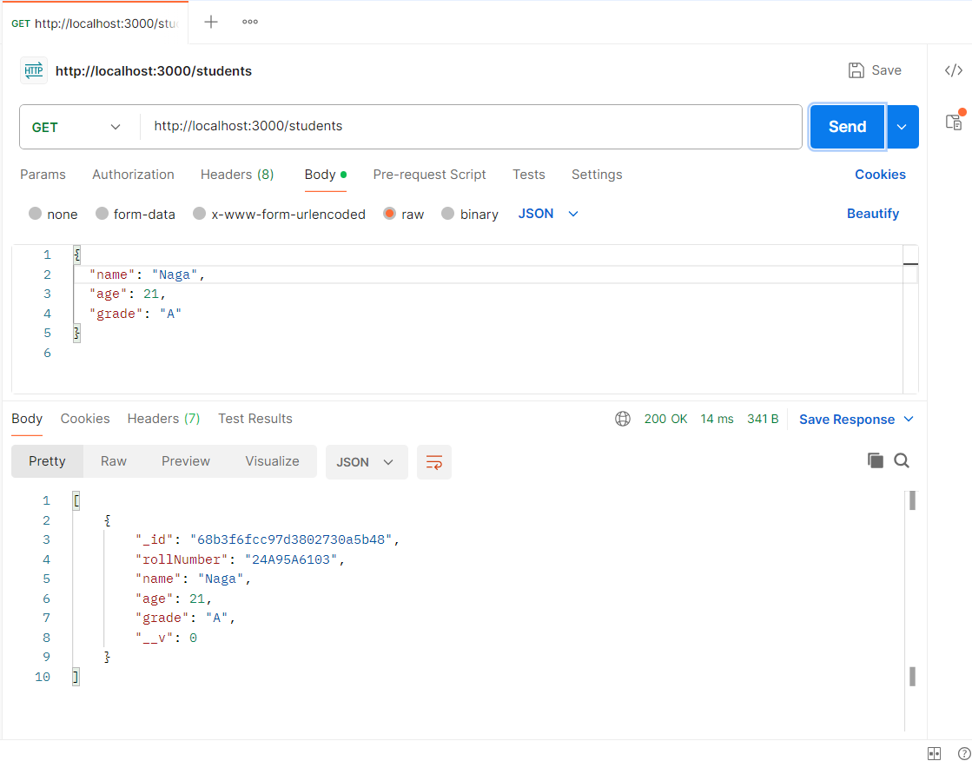

AIM:B) Write a program to develop a single page application using RESTful APIs.

DESCRIPTION:
A Single Page Application (SPA) is a web application that loads a single HTML page and dynamically updates content without reloading the entire page, providing a smoother and faster user experience similar to desktop applications. SPAs interact with a backend server using RESTful APIs, which are HTTP-based services where endpoints correspond to resources (for example, /students) and operations are mapped to standard HTTP methods such as GET for reading data, POST for creating data, PUT for updating data, and DELETE for deleting data. By using JavaScript frameworks or libraries like React, Angular, or Vue.js, the SPA sends API requests, receives JSON responses, and updates the user interface dynamically. This separation between the frontend (SPA) and backend (RESTful API) ensures scalable and maintainable applications. For example, when a user submits a form, the SPA sends a POST request to the API, the server updates the database and responds with JSON, and the SPA immediately updates the displayed content without reloading the page.

SOURCE CODE 1:-
const express=require('express');
const bodyParser=require('body-parser');
const cors=require('cors');
const app=express();
app.use(cors());
app.use(bodyParser.json());
let students=[
{id:1,name:"John",course:"Math"},
{id:2,name:"Jane",course:"Science"},
{id:3,name:"Jim",course:"History"}
];
app.get('/api/students', (req, res) => {
res.json(students);
});
app.get('/api/students/:id', (req, res) => {
const student=students.find(s=>s.id===parseInt(req.params.id));
student?res.json(student):res.status(404).send({message:"Student not found"});
});
app.post('/api/students', (req, res) => {
const newStudent={id:students.length+1,
name:req.body.name,
course:req.body.course
};
students.push(newStudent);
res.status(201).json(newStudent);
});
app.put('/api/students/:id', (req, res) => {
const student=students.find(s=>s.id===parseInt(req.params.id));
if(student){
student.name=req.body.name;
student.course=req.body.course;
res.json(student);
}else{
res.status(404).send({message:"Student not found"});
}
});
app.delete('/api/students/:id', (req, res) => {
students=students.filter(s=>s.id!==parseInt(req.params.id));
res.json({message:"Student deleted successfully"});
});
app.listen(1980, () => {
console.log("Server is running on port 1980");
});

SOURCE CODE 2:-
<!DOCTYPE html>
<html>
<head>
<title>SPA with REST API (CRUD)</title>
<style>
body { font-family: Arial; margin: 20px; }
input, button { margin: 5px; padding: 5px; }
table { border-collapse: collapse; width: 60%; margin-top: 20px; }
th, td { border: 1px solid #ccc; padding: 8px; text-align: center; }
</style>
</head>
<body>
<h3>Roll Number: 24A95A6103</h3>
<h2>Student Management (SPA)</h2>
<div>
<input type="text" id="name" placeholder="Student Name">
<input type="text" id="course" placeholder="Course">
<button id="saveBtn" onclick="addStudent()">Add Student</button>
<button id="updateBtn" onclick="updateStudent()" style="display:none;">Update Student</button>
<input type="hidden" id="studentId">
</div>
<h3>Students List</h3>
<!-- Display your roll number here -->
<table>
<thead>
<tr>
<th>ID</th>
<th>Name</th>
<th>Course</th>
<th>Action</th>
</tr>
</thead>
<tbody id="studentTable"></tbody>
</table>

<script>
const API_URL = "http://localhost:1980/api/students";

// Fetch and display students
async function loadStudents() {
const res = await fetch(API_URL);
const data = await res.json();
document.getElementById("studentTable").innerHTML = data.map(s => `
<tr>
<td>${s.id}</td>
<td>${s.name}</td>
<td>${s.course}</td>
<td>
<button onclick="editStudent(${s.id}, '${s.name}', '${s.course}')">Edit</button>
<button onclick="deleteStudent(${s.id})">Delete</button>
</td>
</tr>
`).join("");
}

// Add new student
async function addStudent() {
const name = document.getElementById("name").value.trim();
const course = document.getElementById("course").value.trim();
if (!name || !course) return alert("Please fill all fields!");

await fetch(API_URL, {
method: "POST",
headers: { "Content-Type": "application/json" },
body: JSON.stringify({ name, course })
});

resetForm();
loadStudents();
}

// Edit student (populate form)
function editStudent(id, name, course) {
document.getElementById("name").value = name;
document.getElementById("course").value = course;
document.getElementById("studentId").value = id;
document.getElementById("saveBtn").style.display = "none";
document.getElementById("updateBtn").style.display = "inline";
}

// Update student
async function updateStudent() {
const id = document.getElementById("studentId").value;
const name = document.getElementById("name").value.trim();
const course = document.getElementById("course").value.trim();
if (!name || !course) return alert("Please fill all fields!");

await fetch(`${API_URL}/${id}`, {
method: "PUT",
headers: { "Content-Type": "application/json" },
body: JSON.stringify({ name, course })
});

resetForm();
loadStudents();
}

// Delete student
async function deleteStudent(id) {
await fetch(`${API_URL}/${id}`, { method: "DELETE" });
loadStudents();
}

// Reset form to default
function resetForm() {
document.getElementById("name").value = "";
document.getElementById("course").value = "";
document.getElementById("studentId").value = "";
document.getElementById("saveBtn").style.display = "inline";
document.getElementById("updateBtn").style.display = "none";
}

// Initial load
loadStudents();
</script>
</body>
</html>
OUTPUT:

